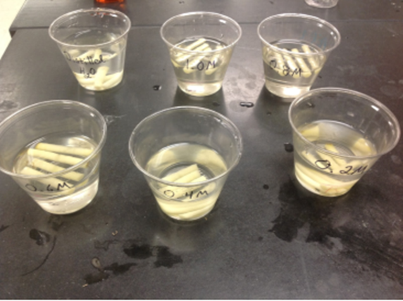 |  | Osmosis experiment write-up  GCSE to BTEC Applied Science—Transition project two
GCSE to BTEC Applied Science—Transition project two  Your task— To use the information provided and your own research on the subject to create a full write-up for the Osmosis potato chip experiment.  It will need to include:  A full method  A results table—correctly formatted with averages calculated.  A graph—With a correct scale, Axis labels. (this can be done on Excel or other software programs)  A conclusion—Explain the results, does it support the hypothesis?  You have been provided with the hypothesis, an equipment list, key measurements used and a rough copy of the results. |  | information provided  Equipment list  Glucose solution of the following concentrations – 0, 0.2, 0.4, 0.6, 0.8  Beakers, Measuring cylinder, Potato, Potato borer, Top pan balance, weighing boat, ruler, scalpel, white tile, stop clock  Hypothesis and key measurements  Measurements - Size of potato chip – 3cm length. Volume of solution used – 30cm³ Length of time left for – 40 minutes.  Hypothesis – The internal concentration of the glucose in the potato can be calculated as at this point the potato neither gains or loses mass.  Rough results gained  Attempt One  0M – Beginning mass 6.14g End mass – 6.92g  0.2M - Beginning mass 6.24g End mass – 6.36g  0.4M - Beginning mass 5.91g End mass – 5.03g  0.6M - Beginning mass 6.30g End mass – 5.05g  0.8M - Beginning mass 5.82g End mass – 4.04g  Attempt Two  0M – Beginning mass 6.52g End mass – 7.30g  0.2M - Beginning mass 5.95g End mass – 6.09g  0.4M - Beginning mass 6.39g End mass – 5.63g  0.6M - Beginning mass 6.23g End mass – 5.06g  0.6M - Beginning mass 6.34g End mass – 4.52g  Additional resources and links  On-line graph paper - https://www.printablepaper.net/category/graph  Osmosis theory - https://www.bbc.co.uk/bitesize/guides/zwkn7p3/revision/4  https://www.bbc.co.uk/bitesize/guides/z22vw6f/revision/5  https://samanthafinglassapbio.wordpress.com/2015/09/11/osmosis-and-its-effects-on-potatoes-in-glucose-solutions/

