UK Politics Project: Who has been the best Prime Minister of recent times?

Your task is to carry out some research into the UK’s recent Prime Ministers and reach a decision about who has been the best. Your work should be set out in the form of a report.
The exact structure and content of your report is up to you but here are some things that I would expect to see you include:
- A list of everyone who has been the UK’s Prime Minister since 1997
- Key facts such as the dates that they were in power and the Party that they belonged to e.g. Conservative, Labour, Liberal Democrat.
- Case studies on three different Prime Ministers. For each case study you need to explain what their successes and failures were and some of the main events that happened during their time in office. I suggest that you give each PM you do a case study on a score /10 to reflect how successful you think they were.
- You might also include details about their image in the media. What kind of a reputation did they have? What were their personality traits? Which groups of people did they tend to be popular and unpopular with? Why?
- In the final section of your report you should do a conclusion with your recommendation for who should be considered the best Prime Minister. You should explain your choice carefully and make an argument about why they deserve to be called the best.

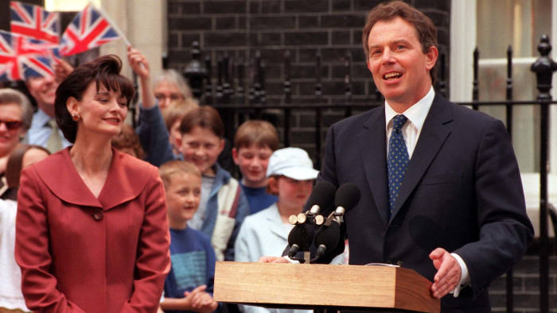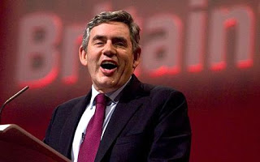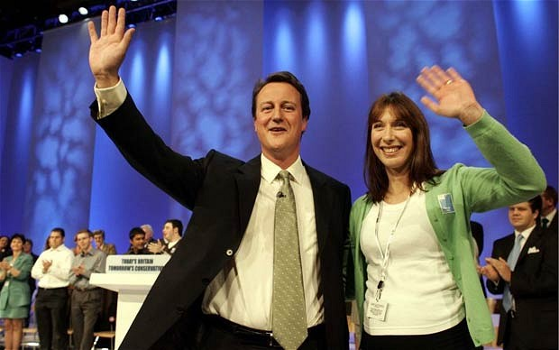
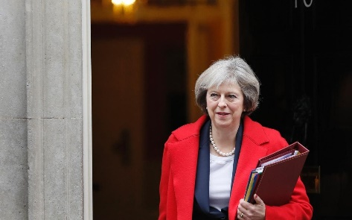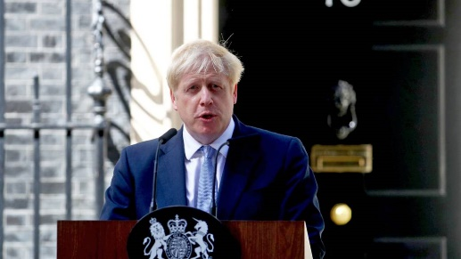

Helpful websites to get you started:
https://www.gov.uk/government/ministers/prime-minister
https://simple.wikipedia.org/wiki/List_of_Prime_Ministers_of_the_United_Kingdom
https://www.britannica.com/biography/David-Cameron
https://www.bbc.co.uk/news/politics
www.youtube.com
Although these will help you get started, you will need to do your own research and find more.
There is no word limit for this piece of work but you should aim to write at least 1500 words. You will be given feedback on what went well and an area for development.
Enjoy!

