Sixth Form Preparation:
Independent Project

The Independent Project
To be successful in Sixth Form and beyond it is essential that you develop independent learning skills. It is also important to learn how to manage longer projects or pieces of work.
This project allows you to develop your personal interest in a topic relating to one or more of your subject choices for Sixth Form.

The skills you'll develop as a result, including project planning, decision making, research skills and evaluation, are invaluable in sixth form, for most jobs and university courses.

It will also help you to demonstrate to us your commitment to study in Sixth Form, your ability to be self-motivated and show your curiosity about your subject(s).

For this project you will:
- Choose an area of interest and develop a project title and aims.
- Plan, research and carry out your project.
- Create an action plan to show the stages of the project.
- Complete the project product.
- Review the outcome of your project and presentation.

Some students may also like to:
- Prepare and deliver a presentation.
- Review the outcome of their presentation.

What should my project look like?
This is up to you! You could choose to write a formal academic report about your research, you could include pictures, titles and other interesting items with this. Or you could decide to create an ‘artefact’ such as a recording of a song, a short film or a website with a brief report about how you achieved this.

You will also include a short evaluation at the end of your project about how you approached it, any problems you experienced and how you overcame them, how you planned out the project and managed your time and any key elements of learning.

Some students may also like to include a presentation about their project to share with teachers, the Sixth Form Team or their peers.

Optional: You may also like to complete this free online course which will help you to develop your research skills: https://www.futurelearn.com/courses/research-project

Task 1: What topic should I choose?

Start thinking about your own interests and passions, why you have chosen your subjects in Sixth Form, what you would like to do in the future at university or as a job/career.

Perhaps there is a particular topic/area within one of your subjects that you are really interested in, or one that links to your future career path. Maybe you have seen a documentary or read a book relating to one of your subjects.

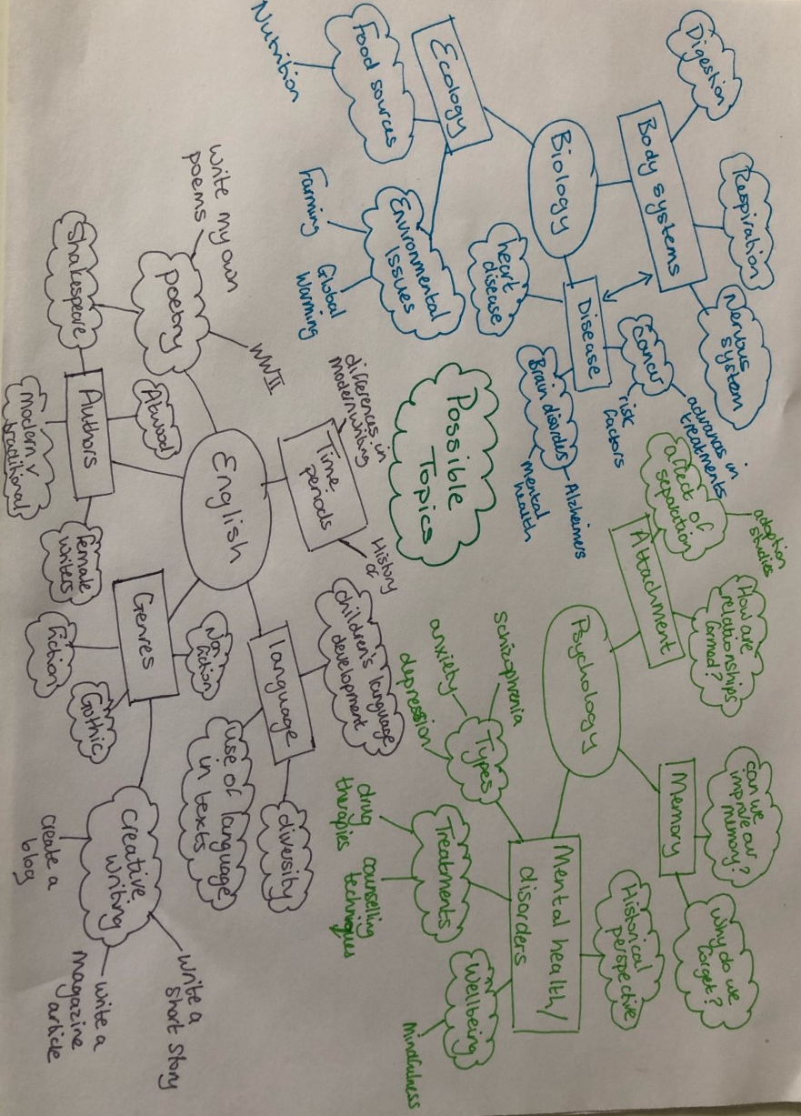
Task: Create a mindmap of topics that you might be interested in researching further. Develop the mind map to show particular areas that you could study.

There may be some topics which overlap across your subjects or some which you are especially interested in or that link to your future career plans. Create a ‘shortlist’ of topics.

Topic shortlist:

Task 2: Develop your ideas

Now carry out some research into each area on your shortlist. You can use Google but try to use reliable sources. You can also use the school online library system.
The aim is to find a really specific area that you would like to focus your project on. You may wish to answer a particular question or evaluate an idea. You may wish to create an artefact and so need to find some similar examples.
Reliable sources
Not everything you read on the internet is reliable. Here are some ways to ensure that the sources you use are suitable:
- Author: Is the information written by a respected author or organisation for this topic?
- Content: What is the focus? Controversial or biased? Factual or just suggesting ideas?
- Timespan: when was the information published? When was it last updated? You may want the most up to date information.
- Geographic area: your topic may be relevant to the UK only therefore your sources must also reflect this.
You should also consider whether the information is relevant to your topic – it is very easy to get carried away with your searches!

Make sure you keep a record of your searches and the information you discover. Complete the table below with the main sources that you find.

Source/Author | URL | Key points
Task 3: Planning

In order to complete a longer project like this it is essential that you create a plan with shorter term goals and timescales for completion.

Some of your goals will need to be broken down into smaller actions in order to achieve them.

All of your goals and actions should be really specific and measurable so that you can show that you have achieved them. Goals should always be SMART:

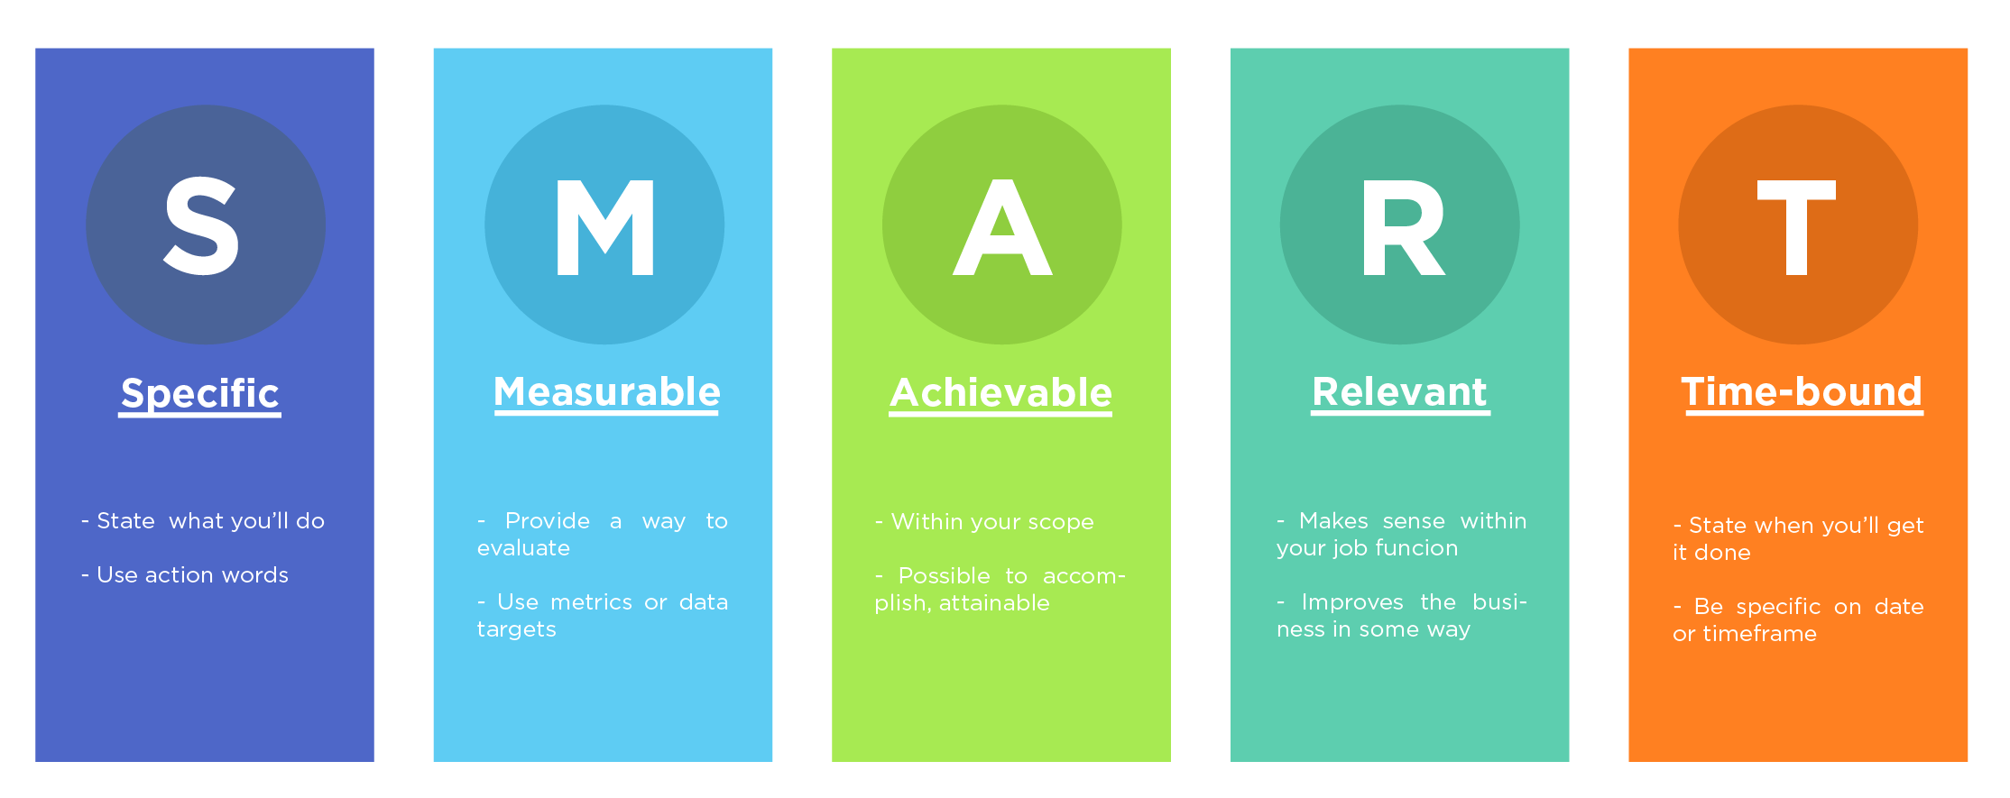

Some of your target dates will need to match up with the hand in times of the tasks.

Task: create an action plan to show how you will complete the project. You can use this template or create your own but it should include similar headings.

Goal | Actions required | Timescale | Date completed
Decide on a title | Initial research to help me decide on a specific topic area or question | 18/5/2020
Carry out research into what makes a good website | - Look for websites with the same purpose as the one I want to create  - Search for information about good websites from reliable sources  - Keep a record of the information I find including the URL
Decide on a platform for my website | Carry out research into free platforms and what they provide

Hand-in deadline 1

Now that you have carried out the planning stage of your project it’s time to send it to the Sixth Form Team to get some feedback on your initial ideas.

You will need to email us at sixthform@tda.education with the following information:

Your name:

The title of your project:

The reason you have chosen this project and title: (please tell us how this fits in with your subject choices for Sixth Form, your career goals, your personal interest and so on).

The initial sources of information that you have found:

Please also attach your action plan.

DEADLINE DATE: Monday 1st June 2020
Summary of feedback given:
(write the comments that you receive from the Sixth Form Team here)

Task 4: Research

Now it’s time to carry out lots of wider research into your topic.

If you are creating an artefact such as writing a poem, creating a short film or writing code for a website, it’s still important to carry out research. For example, you may wish to find good examples of the item you want to create, or guidance on the elements required to create an effective item. You should still ensure that you use reliable sources although they may come from authors or organisations that are well respected in this particular field rather than being more widely known.

If you are writing a report, you will need to decide which areas within your topic you want to find out more about. For example, if you are considering a particular disorder you might want a section with information about how the disorder affects the individual e.g. symptoms, a section about the causes of the disorder and a section about the main treatments or you might just want to focus on one of these areas in more detail for example looking at the causes with a section on genetic causes, one on environmental causes and so on.

Don’t forget to keep a record of all of your sources of information and to use reliable sources throughout.

Topic 1: | Key facts/information
Source 1:

Source 2:

Source 3:

You will need to continue to carry out research as you complete your project.
Task 5: Completing the project

Artefact: if you are creating an artefact you will need to spend time on developing this.
Don’t forget to get feedback from others as you go along. You could even create a short questionnaire about the item you have created and ask friends and family to look at it and then answer the questions. This could be about the methods you have used, the content, the layout or anything else that you think would be useful feedback to help you develop your work.

Report: if you are writing a report you will need to start to put this together.
Don’t forget you should have an introduction to tell the reader what your report is about and the key areas that you intend to cover. You can use headings to show the different points you want to discuss. You must include a conclusion when you draw your points together and, if you had a question in your title, answer the question you set out to solve.

This part of the project will take quite a lot of time. You may need to carry out more research as you go along because you come across an area where you don’t have enough information.

Your title might change during this part of the project – that’s ok, this happens very often in a piece of research or an extended project of this type.

Don’t give up – you are learning some fantastic skills that will be incredibly useful to you as you progress into Sixth Form.

Task: create your artefact (with a brief report about how you did this); or write your report.

You should aim to complete your project by Monday 13th July

Plagiarism
When you have carried out research and are using it to write an essay, report or other work, it is important that you ensure that you are writing in your own words and not in any way copying the original work. Always read the information from the source, then close it and write the key points in your own words. This will ensure that you avoid plagiarism.

Plagiarism in when you suggest that the piece of work is your own but actually it belongs to (or closely resembles) someone else’s work. It is considered to be an act of fraud and is taken very seriously by universities and exam boards, so it is good to learn how to avoid it at this early stage. You will find some useful information about plagiarism here: www.plagiarism.org

At the end of your report you must show all of the sources of information that you used to help you with your project. You can do this by including a list of sources or a bibliography. At this stage the name of the author/organisation/website and the URL is sufficient. Your list should be in alphabetical order.
Task 6: Evaluation

An important element of any project and a key skill for Sixth Form and beyond, is the ability to reflect on your work and to consider your strengths and areas for further development.

Task: write a short evaluation of your project. You should include the following things:
- What you particularly enjoyed about the project
- The key things that you learnt from the project – this could be about your topic or about your own skills!
- What you found most challenging about the project
- What you would do differently if you carried out a similar project in the future

Don’t worry if your project hasn’t gone to plan – that is all part of the evaluation and learning!

Hand-in deadline 2

Now that you have completed your project and evaluation it’s time to send it to the Sixth Form Team to get some feedback.

You will need to email us at sixthform@tda.education with:
Your name:
The (final) title of your project:
Attaching your completed project, evidence of your artefact if relevant and your evaluation.

DEADLINE DATE: Wednesday 15th July 2020
Summary of feedback given:
(write the comments that you receive from the Sixth Form Team here)

Task 7: extension activities

Well done on completing this project – that wasn’t an easy task, but it shows that you are committed to your education, enthusiastic about your subjects and interested in learning more. You have also shown a range of skills that will help you to progress into Sixth Form.
Some of you may like to continue to develop your research and your skills – these extension activities are for you!
Continued research: if you would like to develop your research project further please do so. It may be that you ran out of time to complete the project fully, that you could have developed one of the topics further or that there were other areas that you wanted to explore.
Presentation: following a bigger project such as this, you will often be asked to give a short presentation about your work.
Create a PP or other form of presentation which shows:
- The title of your project
- The main aims i.e. what you wanted to find out about/achieve
- The key findings or photos of your product/artefact
- An evaluation of the strengths of your project
- Areas for further development
- The key skills you developed
- Any other interesting information
You may wish to present this to a small group of your peers, your tutor or members of the Sixth Form Team. You could also consider recording a narrative to your presentation.

Advice for others: create a poster or guidance document to support other students in carrying out a similar project. What advice would you given them? What useful resources have you discovered?

Project ideas
Here are some ideas of topics or titles to help you with your choices:

- An investigation into a current topic in the news relating to one of your subjects
- A debate about a contemporary issue e.g. relating to human or animal rights, a recent case that has come up relating to the law
- Research an important area for your subject e.g. ethics, a current political issue, a historical element and the impact it has had
- Look into a change over a period of time for example how the NHS, education, gender roles etc. have changed over time; an approach to a particular condition/disease; the impact of technology
- Write a short story or (very short) book
- Choreograph a performance (dance, dramatic..)
- Create a website or computer program
- Create a piece of artwork – this could be in the style of a particular artist for example or even an series of pieces or exhibition
- Create a short film or media clip

