Day 2 – Pages 6 and 7

Questions to think about

- Why do you think there were wars that took place?
- Look at the image on page 7, do you think it would have been safe to ride on the carriage? Would you want to do it if you were a soldier during the Shang Dynasty?

Questions to answer

- Why was it important for the king to be assisted by many noblemen and warriors? (2 marks)
- The peasants would fight in the wars as foot soldiers.
What does the word peasants mean in this sentence? (1 mark)
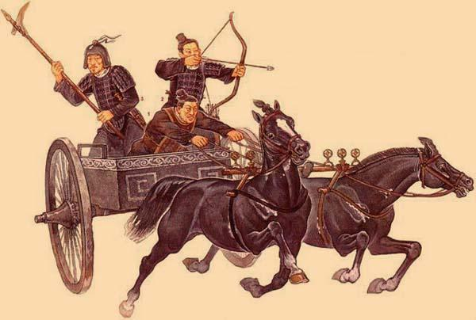
- The Shang Dynasty had a great advantage to help them during battles and wars. What was it? (1 mark)
- In what way were the horses a key component in helping the Shang Dynasty to win battles? (2 marks)
- What was the benefit of using bone or horn for the bows? ( 1 mark)

