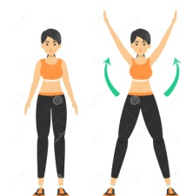
PE activity.
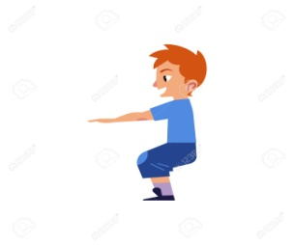
- Warm up!
Please click link to follow warm up: https://www.youtube.com/watch?v=AB1Go5Kpp9k
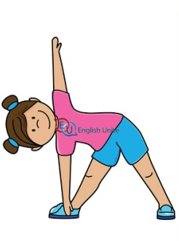
- 10 star jumps
- 10 squats
- 10 windmills
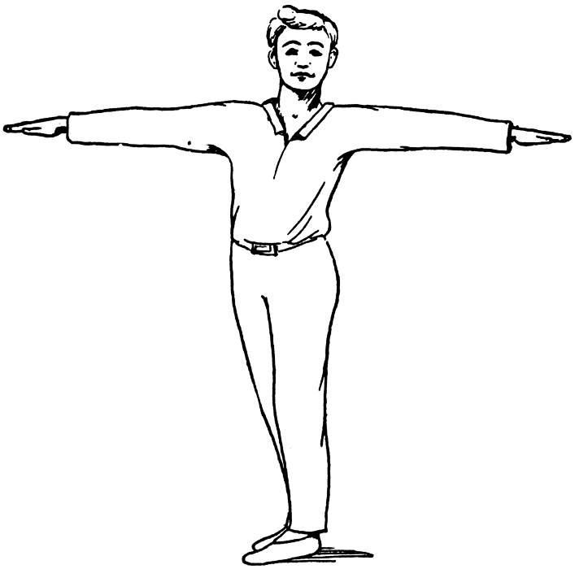
- 10 mini jumps
- 10 side to side jumps
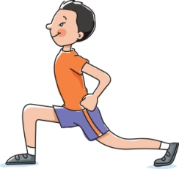
- 10 twists
- 10 lunges

- Children’s yoga!
Yoga is a great form of exercise for children with enormous benefits. Physically, it enhances their flexibility, strength, coordination and body awareness and mentally it improves relaxation and concentration. Yoga can be done in a small space and is great for either outdoor or indoor without any equipment, so accessible for all! Adults please feel free to join in!
Please click on link as follows:
https://www.youtube.com/watch?v=aJzj_b7G7i8

- Children’s dance routines!
Dancing is a great form of exercise, by dancing children can gain greater self confidence, social strengths, increase fitness, flexibility etc. From working with the children I know that the majority of the children love dancing so let’s put that into practice. Adults and siblings feel free to join in!
Here are a few links to some easy to follow dance routines.
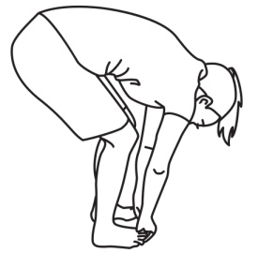
https://www.youtube.com/watch?v=Gzqj7Qf7MQk
https://www.youtube.com/watch?v=cBgWF9VxNEI
https://www.youtube.com/watch?v=o77r2CT8EBY&t=84s

- Cool down!
Please click link to follow warm up:
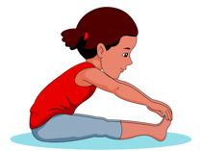
https://www.youtube.com/watch?v=AB1Go5Kpp9k&t=180s
- Touch your toes standing up
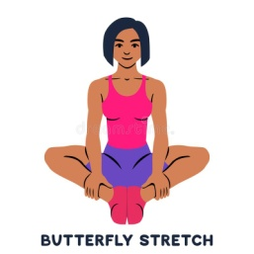
- Quad stretch on both legs
- Touch your toes sitting down
- Butterfly position
- Touch your toes standing up.

- Terminology!
Let’s see if your child can define these key terms, if not let’s look them up in the dictionary.

