Tuesday: Chapter 3

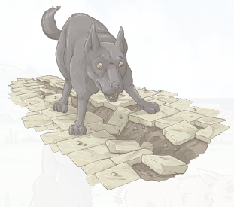
- Why does Alba drop the meat at Livia’s paws?
- Why does Livia back away from the girl?
- What is Alba saved from?
- Which new dog is mentioned in this chapter?
- What is Alba’s opinion of this new dog? Explain how you know.

Chapter 4

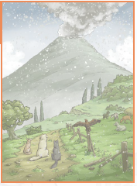
- Why do you think the ground feels warm under the dogs’ paws?
- What does Cato mean by ‘stone nests’?
- What does Cato advise?
- I growl. She steps back and lowers her head. Do you think that Livia was being fair to Claudia at this point in … .the story?
- What do you predict will happen next in the story? Explain your answer.

