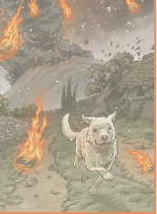
Wednesday: Chapter 5

- The mountain’s fury tears great claw marks across the earth and bundles me off my feet, pulling down walls and toppling olive trees.
Give an example of personification from the sentence above.
- What are the ‘great claw marks’ described in the sentence above?
- How do you think the girl feels when Livia reaches her?
- Define ‘betrayed’.
- What does the writer mean by ‘the Gentle Mountain has betrayed us ….all’?

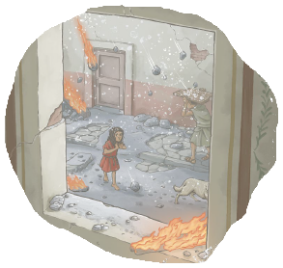
Chapter 6
- Find and copy a word in the second paragraph which means to ‘gently push’.
- Define ‘melee’.
- Why do you think that the streets are less crowded?
- How do you think Livia felt when she saw Claudia and Alba?
- Suggest why the author ended the chapter with ‘CRASH’.

