The Time-Traveller
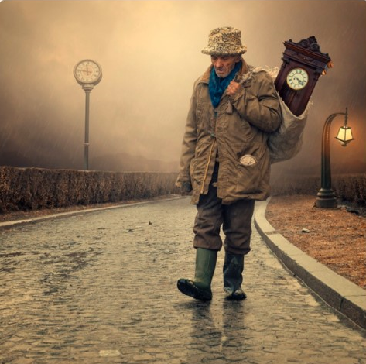

Can you continue the story of the time-traveller? Consider where he may have been, whether it be into the past or the future. Discuss some of the things he has seen and people he has met. Perhaps he is on a mission now. Remember, if he is in the past and he changes something significant, it could change the future forever…

Is there more past or future?
If you could travel back in time, would you change anything from your past?
If you could see into the future, what would you like to see yourself doing in 10 years time?
Why do you think the character is 'plodding' along? What does that tell you?

The Time-Traveller

The traveller plodded slowly across the long, cobbled bridge. Rain spat from the sky, pounding against the cold road, mist and cloud blocking any sunlight that could brighten the occasion.

He could feel the clock digging into his back as he walked. It went everywhere with him, or rather he went everywhere with it. The clock was the key to everything; the key to moving through time and space. It was what had allowed him to see everything that had been, and everything that had not yet come to pass.

Life as a time-traveller had its benefits, but it also took its toll…

