Uprooted
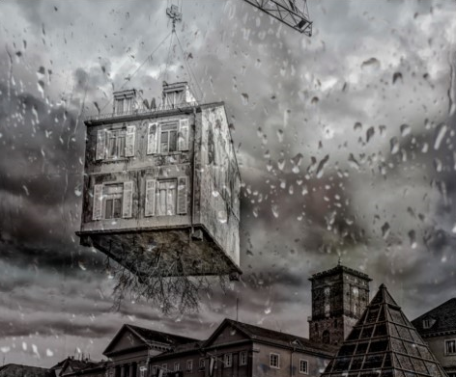
Can you continue the story?
Who does the house across the street belong to? Does Amelie know them?
What will be revealed when the curtain is drawn back?
What part of the world do you think this story is set in? Look for clues in the picture.
Who do you think Amelie lives with? How old do you think she is?
What is causing the house to be uprooted? Who is controlling these events?

Uprooted

Amelie stared out in disbelief. Despite the incessant drip, drip, drip of the rain as it continued to attack her bedroom window, she couldn't tear her eyes from the bizarre events unfolding outside.
Just a minute or so earlier, Amelie had been staring out into the street enjoying the peaceful and familiar sight of ordinary life as it passed her by. Now, however, she simply couldn't believe what was happening; the house belonging to a very pleasant family across the road had suddenly been thrust up into the air! It was now swaying in mid air!
Much to Amelie's horror, the curtains were then thrown wide open...

