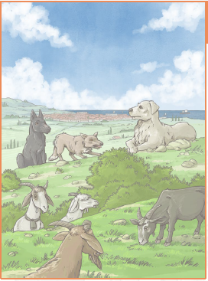
Monday: Chapter 1

- Why does Claudia limp?
- What is indicated by Claudia’s ears being flattened against her head?
- Why did the dogs agree to go into the town?
- What is suggested by the actions of the horses at the end of the chapter?
- What do you predict will happen next?

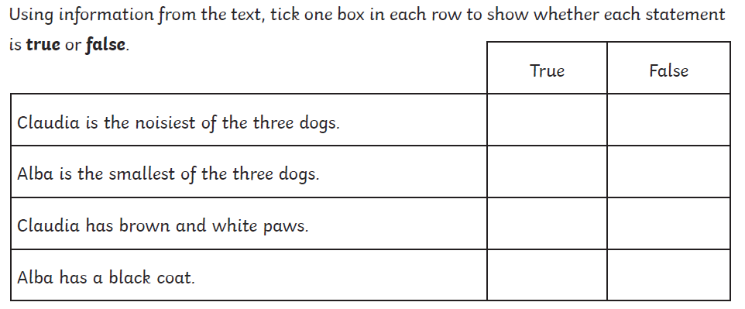

Chapter 2

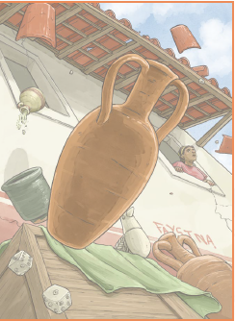
- Define ‘scampers’.
- In the third paragraph, what is suggested by the words ‘violent urgency’?
- Name two things that the two-legs are doing in the town.
- Can you give an example of personification in the fourth paragraph?

