Fun dance routines to try at home.
Dance is a great form of exercise and it can be really fun for everyone to do! Before you try any of the routines, we need to make sure were warmed up! Follow the link bellow to get your sweat on. https://www.youtube.com/watch?v=dRQf3yFXO1Y
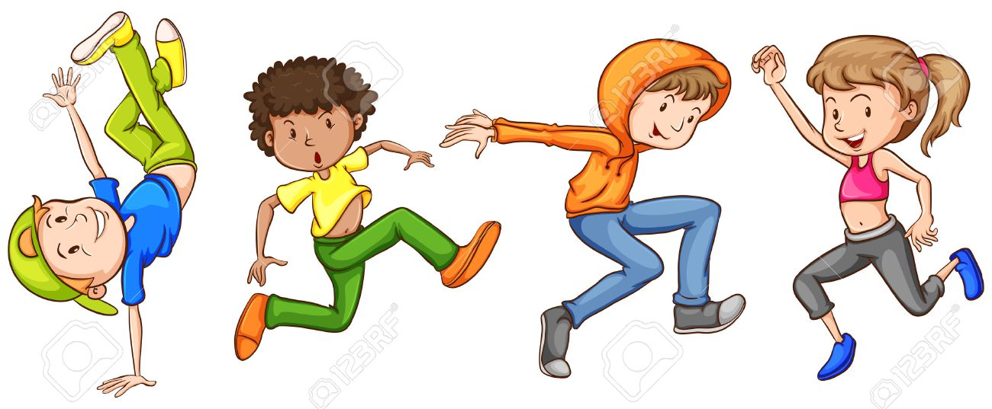
- A dance routine to try for any ages! Just dance is a console game, with sensors to determine whether your child is copying the dancers. Although a fun free option is to go on the Just Dance Youtube channel I will link some dances bellow to follow, all you need to do is copy their moves. I know the children loved practising their dance routines. So let’s get all the family involved!
https://www.youtube.com/watch?v=gCzgc_RelBA https://www.youtube.com/watch?v=eughyYPoExk
https://www.youtube.com/watch?v=QCKKGMfFa9c

