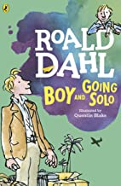
Year 7 Top Ten Reading List
Boy and Going Solo by Roald Dahl; autobiography
Learn more about the fascinating life of the man who brought you Willy Wonka and Miss Trunchbull with stories from the author’s childhood and years in the Air Force during World War II. Can you spot the people and events that influenced his writing?

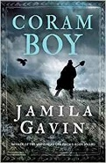
Coram Boy by Jamila Gavin; historical, human rights
Toby, an African, and Aaron, the illegitimate heir to a great estate, are linked by the Coram Man, a shady figure who supposedly delivers abandoned children to a safe new life at the Coram Hospital. The reality is much, much worse. Join Toby and Aaron on an epic journey through 1750s Britain, fraught with danger and excitement.
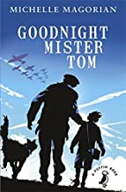
Goodnight Mister Tom by Michelle Magorian; WWII Family drama
Willie is evacuated from wartime London and goes to live with the irritable but kindly Mr Tom. They both learn being family is more than sharing the same blood. An unforgettable story of heartbreak and hope.
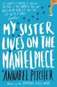
My Sister Lives on the Mantlepiece by Annabel Pitcher; family issues, diversity
Told through the eyes of ten-year-old Jamie, this novel sensitively tackles issues around family breakdown after grief. It also explores terrorism, racism and bullying issues from a child's point of view.
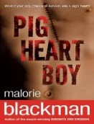
Pig Heart Boy by Malorie Blackman; personal and social issues
Cameron is seriously ill; a controversial transplant could save his life but that is only the beginning of his struggle. Powerful and thought provoking.
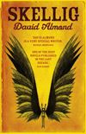
Skellig by David Almond; fantasy, adventure
Exploring a ramshackle garage with his new-found friend Mina, Michael discovers a strange, magical creature who needs his help. A contemporary classic.

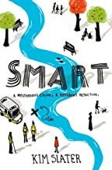
Smart by Kim Slater; detective thriller
A homeless man has been murdered and the police don’t care; but Kieran does and he’s going to solve the case. Being a detective is difficult when you're amazing at drawing but terrible at fitting in. And when there are dangerous secrets everywhere, not just outside, but under your own roof.
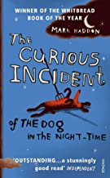
The Curious Incident of the Dog in the Night-time by Mark Haddon; adventure, disability
A complex investigation begins with the discovery of a neighbour’s dead dog and leads Christopher, who is autistic, to many unexpected discoveries, including about his own family. Hilarious and ingenious in equal measure.
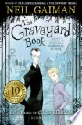
The Graveyard Book by Neil Gaiman; fantasy, ghost story
When Bod’s parents are killed, he goes to live in the local graveyard where he is raised and protected by the ghosts who haunt the cemetery – but the murderer is still out there and they are searching for Bod. Step into the gothic – if you dare!
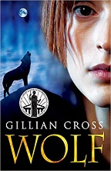
Wolf by Gillian Cross; family drama
Casey reunites with her beautiful but simple mother after years apart and tries to settle into her new life but there are many questions about her past. Does she really want to know the answers?

