Name
Form
Teacher
Target Level

Spelling Test No 6
1)
2)
3)
4)
5)

Spelling Test No 5
1)
2)
3)
4)
5)

Spelling Test No 4
1)
2)
3)
4)
5)

Spelling Test No 3
1)
2)
3)
4)
5)

Spelling Test No 2
1)
2)
3)
4)
5)

Spelling Test No 1
1)
2)
3)
4)
5)

CURRICULUM LEVEL | I MUST SHOW THAT I | SELF ASSESSMENT | TEACHER ASSESSMENT
1 | - Write simple programs using a high level programming language
2/3 | - Learn about data types  - Learn how to display statements using the Python GUI  - Learn how to store different variables.  - Design and create program  - Debug programs that accomplish specific goals  - Use repetition and loops in programs
4 | - Solve problems by decomposing them into smaller parts  - Use selection in programs  - Work with variables  - Use logical reasoning to explain how some simple algorithms work  - Use logical reasoning to detect and correct errors in algorithms
5 | - Use procedures and functions with parameters in your programs.  - Use computational abstractions  - Model state of real world problems  - Use a programming language to solve computational problems  - Use procedures and functions with parameters in your programs.

Date: |  | Lesson Number | 1
Learning Objective/s: | - Learn about the Python Interface  - Learn to write a simple program to display a phrase.
Plenary: | Have you met todays learning objectives? Tick () the ones you have and cross () the ones you haven’t above.
What I have learnt this lesson?
Starter
What do you think programming is?

Lesson 1 Activity 1: “Hello World”
At the command prompt, type the words below, exactly as they appear (remember to use lower case):
>>>print(“Hello World”)

The phrase Hello World should appear immediately below the print as shown below:
>>>print(“Hello World”)
Hello World
>>>

Now type the message below, exactly as it appears:
>>>print(Hello World)
What happened when you pressed enter?
(write out the message)

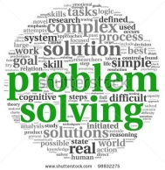
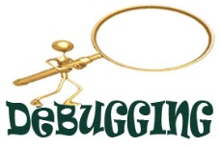 Code Lesson 1 Activity 2
Code | Try this and write down what happened?
>>>print”Hello World”

>>>print(“Hello World”);

>>> Print(“Hello World)

>>>print(‘Hel World”)

>>>prin(Hello World)

What have you learnt from the activity above? What will create syntax errors in your code? Identify some ‘rules’ here:
…………………………………………………………………………………………………………………………………………………………………………………………………………………………………………………

Date: |  | Lesson Number | 2
Learning Objective/s: | - Learn how to write several lines of code spread over different lines  - Learn about the “print” command
Plenary: | Have you met todays learning objectives? Tick () the ones you have and cross () the ones you haven’t above.
What I have learnt this lesson?
Lesson 2 Activity 1 (Print Command)

Look and type out the following code and answer the questions below
Print(“Hello!)
Print(“How are you”)
Print(“Have you had a good day so far?”)

Question 1: Explain the above code

………………………………………………………………………………………………………………………………………………………………….
………………………………………………………………………………………………………………………………………………………………….
………………………………………………………………………………………………………………………………………………………………….

Question 2: What is the purpose of the Print Command?
………………………………………………………………………………………………………………………………………………………………….
………………………………………………………………………………………………………………………………………………………………….
………………………………………………………………………………………………………………………………………………………………….

Extension: Type out your own Print Commands asking questions such as

What is today’s day?

Where are you from?

What are you looking forward to this weekend?

Lesson 2 Activity 2 (Comments)
Comments are bits of text in the program code that are not used by the computer, but help to explain what is going on.
You can write a comment using a # symbol.
Try this program:
#This is a comment
print("This is not a comment.")

type out the following code and answer the questions below

Copy out the following codes and add #comments also.
Print(“Hello!)
#Here the code display’s the word Hello
Print(“Have you had a good day so far?”)
#Here the code displays a question
Task: Explain why adding comments helps programmers.
………………………………………………………………………………………………………………………………………………………………….
………………………………………………………………………………………………………………………………………………………………….
………………………………………………………………………………………………………………………………………………………………….
Lesson 2 Activity 3

Try this \n command at any point in a line of text will force a new line:

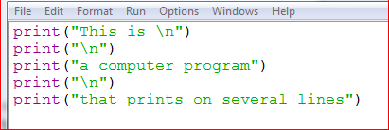
Task: Copy out the code above
Explain why doing this would help a programmer.
………………………………………………………………………………………………………………………………………………………………….
………………………………………………………………………………………………………………………………………………………………….
Date: |  | Lesson Number | 3
Learning Objective/s: | - Learn about storing variables using Python
Plenary: | Have you met todays learning objectives? Tick () the ones you have and cross () the ones you haven’t above.
What I have learnt this lesson?
Ticks ()
Variables
We need a mechanism for tracking values and changes of values in a program. We do this in high level programming by using what we term as “variables”.
A typical variable usage would be
a = 6
This assigns the value of 6 to the variable “a”

Lesson 3 Activity 1 Try this….

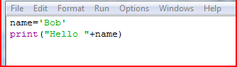

Lesson 3 Activity 2
We can change the value of a variable within the program. Try running this code and explain what happened:

………………………………………………………………………………………………………………………………………………………………….
………………………………………………………………………………………………………………………………………………………………….

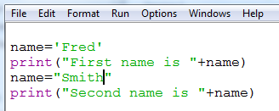

Explain what happened…

………………………………………………………………………………………………………………………………………………………………….
………………………………………………………………………………………………………………………………………………………………….

Lesson 3 Activity 3
Try this.

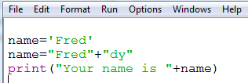

Explain what happened…

………………………………………………………………………………………………………………………………………………………………….
………………………………………………………………………………………………………………………………………………………………….

………………………………………………………………………………………………………………………………………………………………….
………………………………………………………………………………………………………………………………………………………………….

Date: |  | Lesson Number | 4
Learning Objective/s: | - Learn about calculations using Python  - Learn about subtraction, addition, division and multiplication symbols.  - Learn how to store numbers as variables.
Plenary: | Have you met todays learning objectives? Tick () the ones you have and cross () the ones you haven’t above.
What I have learnt this lesson?
Ticks ()
Calculations: We can carry out calculations in Python. The arithmetic operators we use to do this are:

+ | addition
- | subtraction
* | multiplication
/ | division

Lesson 4 Activity 1
Try the following code.
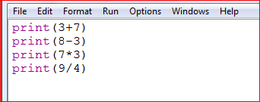

Explain what happened…

………………………………………………………………………………………………………………………………………………………………….
………………………………………………………………………………………………………………………………………………………………….

Lesson 4 Activity 1b
Using Python, copy out the following codes and answer the questions below.
Lesson 4 Activity 2
Copy and run this program:

Copy out the code above.
What does the code do?
………………………………………………………………………………………………………………………………………………………………….
………………………………………………………………………………………………………………………………………………………………….

Date: |  | Lesson Number | 5
Learning Objective/s: | - Learn about strings  - Learn about lists  - Learn how to store data using machine code.
Plenary: | Have you met todays learning objectives? Tick () the ones you have and cross () the ones you haven’t above.
What I have learnt this lesson?
Ticks ()

Lesson 5: Activity 1 – Using Strings
A string in a program is a block of text which can include letters, numbers or symbols.
In a new program window, create a string to include all the names of the rollercoaster rides using the code below.
Copy out the code above.
What does the line print allRides do?
………………………………………………………………………………………………………………………………………………………………….
………………………………………………………………………………………………………………………………………………………………….

………………………………………………………………………………………………………………………………………………………………….

Lesson 5: Activity 2 – Using Lists
It is often more useful to store information as a list instead of a string. This is similar to an array in other programming languages.
Write a new program in a new window which stores each type of ride in a list
What is printed on screen this time when you ran the code?
………………………………………………………………………………………………………………………………………………………………….
………………………………………………………………………………………………………………………………………………………………….

………………………………………………………………………………………………………………………………………………………………….

What happens if you type print allRides[0] into the python shell?
………………………………………………………………………………………………………………………………………………………………….
………………………………………………………………………………………………………………………………………………………………….

………………………………………………………………………………………………………………………………………………………………….

What happens when you type print allRides[4:6] into the python shell?
………………………………………………………………………………………………………………………………………………………………….
………………………………………………………………………………………………………………………………………………………………….

………………………………………………………………………………………………………………………………………………………………….

Lesson 5: Activity 3 – Dictionary’s
Another data type in Python is a Dictionary (sometimes called a Map). This is similar to a list but has a key which can be used to find the information quickly.
Copy out the code below
What happens if you type printfavouriteRide(“Jenny”) into the python shell?
………………………………………………………………………………………………………………………………………………………………….
………………………………………………………………………………………………………………………………………………………………….

What happens if you type printfavouriteRide(“Cara”) into the python shell?
………………………………………………………………………………………………………………………………………………………………….
………………………………………………………………………………………………………………………………………………………………….

Modify the code above to add two more people and rides. Explain what happened.
………………………………………………………………………………………………………………………………………………………………….
………………………………………………………………………………………………………………………………………………………………….

Date: |  | Lesson Number | 6
Learning Objective/s: | - Learn about the IF Statement  - Learn about operators  - Learn about indentation.
Plenary: | Have you met todays learning objectives? Tick () the ones you have and cross () the ones you haven’t above.
What I have learnt this lesson?
Ticks ()

Load up the file “IF statement task.xls”
Your teacher will demonstrate this task and you need to complete this activity.

A Boolean condition is one that can have only two values true or false (1 or 0, yes or no).

The boolean comparison operators used in python are as follows:

Operator | Meaning
= = | Equal to
! = (<> is out of date now) | Not equal to
< | Less than
> | Greater than
<= | Less than or equal to
>= | Greater than or equal to

Lesson 6 Activity 1 Copy out the following code.

Explain what happened.
………………………………………………………………………………………………………………………………………………………………….
………………………………………………………………………………………………………………………………………………………………….

Now adjust the comments for the following scenarios
- To have a credit card at the age of 18
- To collect a pension at 67
- To go see X Men Film with “12 Certificate”

Copy out the code above. Explain what happened.
………………………………………………………………………………………………………………………………………………………………….
………………………………………………………………………………………………………………………………………………………………….

Copy out the code above. Explain what happened.
………………………………………………………………………………………………………………………………………………………………….
………………………………………………………………………………………………………………………………………………………………….

Date: |  | Lesson Number | 7
Learning Objective/s: | - Learn about the IF and IF ELSE statement  - Learn about operators  - Learn about arrays.
Plenary: | Have you met todays learning objectives? Tick () the ones you have and cross () the ones you haven’t above.
What I have learnt this lesson?
We can tell the computer to do something different when the condition isn’t true using the else keyword.

You can extend the IF statement by using an abbreviation of the ELSE IF Function in Python this is written elif.

For more complex conditions we can use and to create a range between two numbers.

Lesson 7 Activity 1

Copy out the following code.

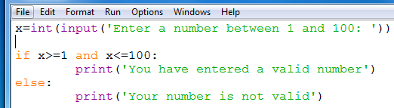

Copy out the code above. Explain what happened.
………………………………………………………………………………………………………………………………………………………………….
………………………………………………………………………………………………………………………………………………………………….

………………………………………………………………………………………………………………………………………………………………….

Lesson 7 Activity 2

Copy out the code above. Explain what happened.
………………………………………………………………………………………………………………………………………………………………….
………………………………………………………………………………………………………………………………………………………………….

………………………………………………………………………………………………………………………………………………………………….

Copy out the code below.

Lesson 7 Activity 3

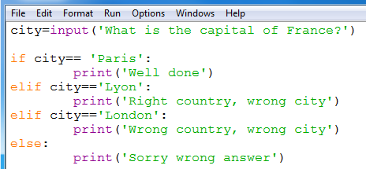

Below is a program that asks for three numbers and outputs SNAP if they all match. Use your knowledge of the and, or and not operators to make the program more efficient.

Lesson 7 Activity 4

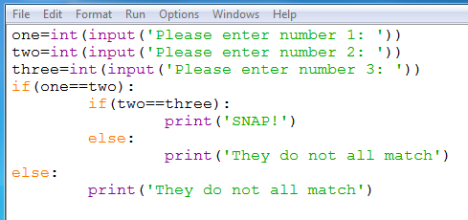

Lesson 7 Activity 5: Arrays
An array is a collection of words, numbers or objects that will follow a specific pattern. In programming you may wish to store a set of names and associate these names with a number.
E.g. storing someone’s age, address or phone number in a database.

Copy out the code. Explain what happened.
………………………………………………………………………………………………………………………………………………………………….
………………………………………………………………………………………………………………………………………………………………….

………………………………………………………………………………………………………………………………………………………………….

Date: |  | Lesson Number | 8
Learning Objective/s: | - Recap n/ commmand  - Learn about creating Menu’s  - Learn about storing variables and recap the print command.  - Learn about the len() command
Plenary: | Have you met todays learning objectives? Tick () the ones you have and cross () the ones you haven’t above.
What I have learnt this lesson?

Lesson 8 activity 1 Copy the code

Copy out the code above. Explain what happened.
………………………………………………………………………………………………………………………………………………………………….
………………………………………………………………………………………………………………………………………………………………….

………………………………………………………………………………………………………………………………………………………………….

The Len is used to denote the length of a string. Remember, Len counts the number of spaces.

Copy out the code above. Explain what happened.
………………………………………………………………………………………………………………………………………………………………….
………………………………………………………………………………………………………………………………………………………………….

Date: |  | Lesson Number | 9
Learning Objective/s: | - Learn about using Python Turtle graphics  - Learn about movement using Turtle (FW, LEFT)
Plenary: | Have you met todays learning objectives? Tick () the ones you have and cross () the ones you haven’t above.
What I have learnt this lesson?
Ticks ()
Starter

Try this command…

import random
x = random.randrange(100)
print x
Lesson 9 Activity 1
Using a suitable search engine, find out what the following codes to and provide an explanation on the right hand side.
Code
Program
Variable
Loop
Else
IF
ELIF
While
For

Try this…..

Copy out the code above. Explain what happened.
………………………………………………………………………………………………………………………………………………………………….
………………………………………………………………………………………………………………………………………………………………….

Now try this to create a Green Square.

Lesson 9 Activity 1 - Fill Colours
We can change the fill colour as well as the line colour, although we need to specify if we want a shape to be filled too! The code below uses the commands begin_fill() and end_fill() to state when to start and stop using the fill colour.

Now experiment with the Turtle codes using the comments overleaf.

